Observer Pattern:
The observer pattern define the one to many dependency between the objects. So that when one object changes state all of its dependency are notified and updated automatically.

Observable(or subject): this is the object that changes its value and all the other objects are listening to its change.

Observer: these are the objects listening to the changes in observable

UML Diagram:
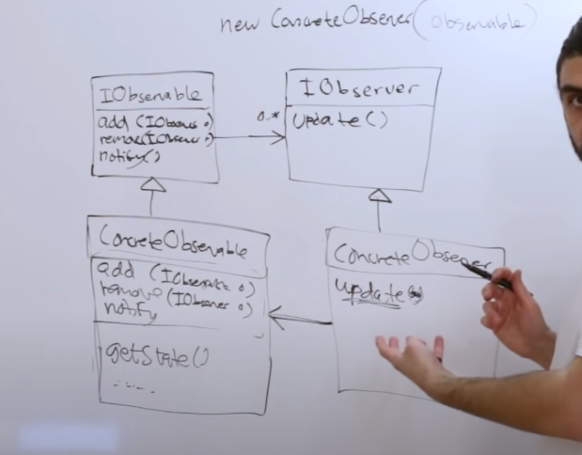
Components:
Iobservable: this is the interface that has 3 methods
1) Add(): it add the observer to the observer list
2) Remove(): it remove the observer from the observer list
3) Notify(): it notify every observer that the observable has been changed

Iobserver: this is the interface for observers that has one method
1) update(): whenever the observable notify observers at that time the observers update there data.

ConcreteObservable: It is a Iobservable(inheritence). It has one extra methoda.
1) getState(): return the currrent state of observable.

ConcreteObserver: it is a Iobserver.

RelationShip:
1) Iobservable has a many Iobservers.
2) concreteObserver has a single concreteObservable: It is useful because when we will call the update function then we can get the current state of given concreteObservable with the help of this concreteObservable (getstate method).

Example:
